Rossmoyne SHS
Mathematics Department
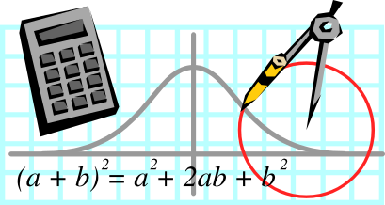

MATHEMATICS 2A B

2010 Examination

Section Two: Calculator-Assumed

TEACHER:-
(Circle one name) FLETCHER TANDAY

SOLUTIONS

Time allowed for this section
Reading time before commencing work: 10 minutes
Working time for paper: 100 minutes

Material required/recommended for this section

To be provided by the supervisor
This Question/Answer booklet
Formula sheet (retained from Section One)

To be provided by the candidate
Standard items: pens, pencils, pencil sharpener, eraser, correction fluid, ruler, highlighters

Special items: drawing instruments, templates, notes on two unfolded sheets of A4 paper, and up to three calculators satisfying the conditions set by the Curriculum Council for this course.

Important note to candidates

No other items may be used in this section of the examination. It is your responsibility to ensure that you do not have any unauthorised notes or other items of a non-personal nature in the examination room. If you have any unauthorised material with you, hand it to the supervisor before reading any further.

Structure of this paper

Section | Number of questions available | Number of questions to be answered | Working time (minutes) | Marks available
Section One:  Calculator-free | 6 | 6 | 50 | 40
Section Two:  Calculator-assumed | 13 | 13 | 100 | 80
 |  |  |  | 120

Instructions to candidates

- The rules for the conduct of Western Australian external examinations are detailed in the Year 12 Information Handbook 2010. Sitting this examination implies that you agree to abide by these rules.

- Write your answers in the spaces provided in this Question/Answer Booklet. Spare pages are included at the end of this booklet. They can be used for planning your responses and/or as additional space if required to continue an answer.
- Planning: If you use the spare pages for planning, indicate this clearly at the top of the page.
- Continuing an answer: If you need to use the space to continue an answer, indicate in the original answer space where the answer is continued, i.e. give the page number. Fill in the number of the question(s) that you are continuing to answer at the top of the page.

- Show all your working clearly. Your working should be in sufficient detail to allow your answers to be checked readily and for marks to be awarded for reasoning. Incorrect answers given without supporting reasoning cannot be allocated any marks. For any question or part question worth more than two marks, valid working or justification is required to receive full marks. If you repeat an answer to any question, ensure that you cancel the answer you do not wish to have marked.

- It is recommended that you do not use pencil except in diagrams.

Section Two: Calculator-assumed (80 Marks)
This section has thirteen (13) questions. Answer all questions. Write your answers in the space provided.

Working time for this section is 100 minutes.

Question 7 (4 marks)
In the scalene triangle shown below (not drawn to scale) it is known that the angle 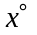 is 7° more than twice the size of angle 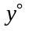.
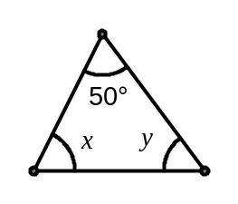
(a) Using the above information and your knowledge of triangles, write down two equations involving and . (2 marks)
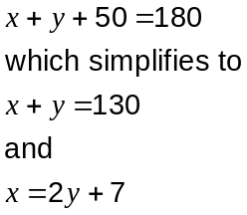

(b) Solve your equations in (a) to find the sizes of angles and . (2 marks)
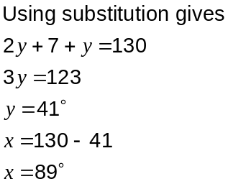

Question 8 (8 marks)
A group of adults were surveyed on how much money they had donated to a charity following a TV advertising campaign. The results are displayed in the histogram below.
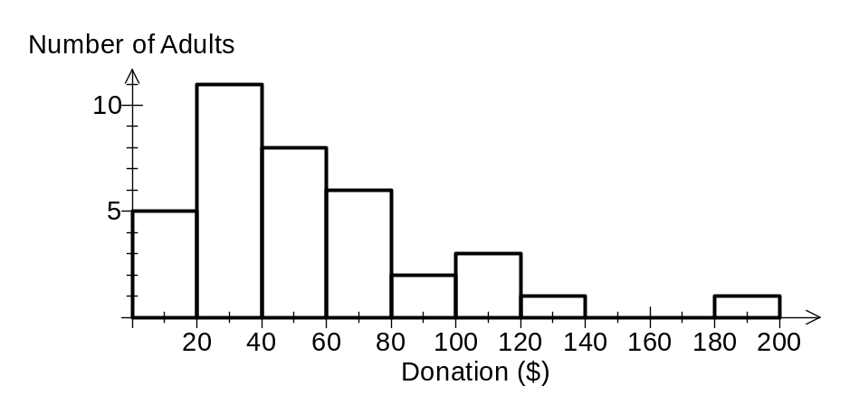
(a) How many adults were surveyed? (1 mark)

(b) State the modal class interval. (1 mark)
$20 - $40

(c) Use the class midpoints to calculate the mean donation. (2 marks)

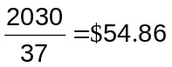

(d) Which class interval contains the median? (1 mark)
$40 - $60

(e) Describe the spread of the data. (3 marks)
The range of the donations is $200.

There is an outlier in the $180 - $200 interval.

The donations are more spread out above the mean/mode/median than below.

Question 9 (7 marks)
The network below shows the times in minutes to drive between various towns.

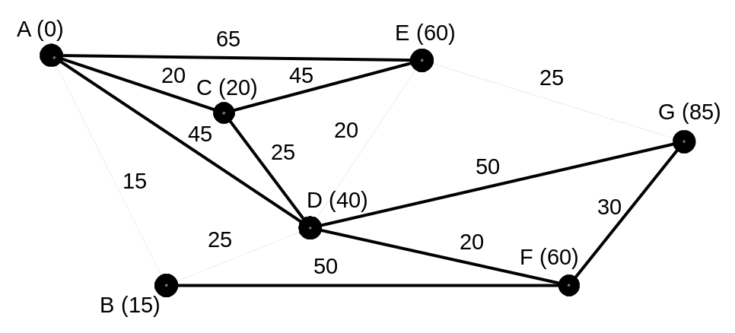

(a) A motorist is looking for the quickest route from town A to town G.

(i) Determine the quickest route, showing your working on the diagram above.
(3 marks)
85 minutes

(ii) List the towns on the quickest route. (1 mark)
A - B - D - E - G

(b) Just before setting out, the motorist learns that road works are causing delays of 7 minutes when passing through town C and 8 minutes when passing through town D.

(i) If the motorist uses the route found in part (a), what effect does this have on their journey time? (1 mark)
Increases time by 8 minutes.

(ii) The motorist can save time by using a different route from town A to town G. State this new route and the time this route would take including the delay. (2 marks)
Use A - E - G which takes 90 minutes.

Question 10 (8 marks)
(a) At a supermarket, a certain brand of coffee is sold in four different sizes: 125g for $2.95, 200g for $4.70, 375g for $8.70 and 500g for $11.95. On the price tag of the 200g size is displayed the information $2.35 per 100g of coffee. Calculate the price per 100g for the other three sizes and hence state the most economical size to buy if price is the only factor to consider. (3 marks)
2.95 ÷ 1.25 = $2.36

8.70 ÷ 3.75 = $2.32

11.95 ÷ 5 = $2.39

The 375g is best buy.

(b) At a certain cinema, the price of a movie ticket is $15.50.

(i) The cinema sells a book of 20 movie tickets with a discount of 12% off the regular price. What is the price of the book of 20 tickets? (2 marks)
20 × 15.50 = 310

310 × 0.88 = $272.80

(ii) The price of a movie ticket is to be increased by 8%.What is the new price, correct to the nearest 5c? (1 mark)
15.50 × 1.08 = 16.74

Price is $16.75 to nearest 5c.

(c) A sales person received a percentage commission of the value of sales each month. Following sales of $7960 in one month their commission amounted to $99.50. What was the percentage rate of commission? (2 marks)
99.50 ÷ 7960 = 0.0125

0.0125 × 100 = 1.25%

Question 11 (5 marks)
Three points have coordinates A(-4, 3), B(2, 0.5) and C(-3, -4).
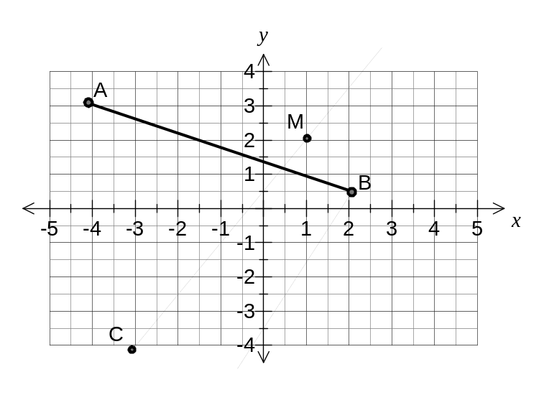
(a) Plot and join the points A and B and calculate the distance between them. (2 marks)
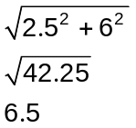

(b) A straight line through B has a gradient of 2. Determine the coordinates of the point where this line intersects the y-axis. (1 mark)
From diagram, point is at (0, -3.5)

(c) The midpoint of C and a fourth point D lies at M(1, 2). Find the coordinates of D.
(2 marks)
From C to M, go 4 units right and 6 units up.

So D must be 4 units right and 6 units up from M.

D(5, 8).

Question 12 (7 marks)
The solid figure below consists of a cylinder of radius 12cm and height 7cm with a cone of the same radius and slant height 12.5cm placed on top.
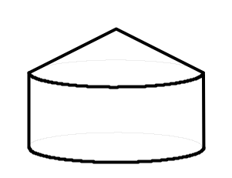

(a) Determine the total surface area of this solid figure. (3 marks)
Cylinder (curved side and circular base)

Cone (curved area only)
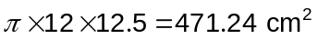

TSA

(b) Show that the total height of the solid figure is exactly 10.5cm. (2 marks)
Using 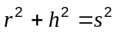 for cone:
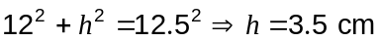

Total height is 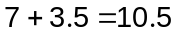cm.

(c) Determine the total volume of this solid figure. (2 marks)

Cylinder
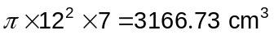

Cone
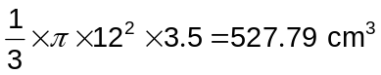

Total volume

Question 13 (7 marks)
A company specialises in restoring old photographs. The times spent restoring nine photographs of different ages are shown in the table below.

Age (Years) | 49 | 67 | 44 | 85 | 58 | 73 | 62 | 65 | 71
Time (minutes) | 95 | 120 | 90 | 145 | 110 | 130 | 950 | 115 | 130

(a) Construct a scatter plot for this data on the axis below. (3 marks)
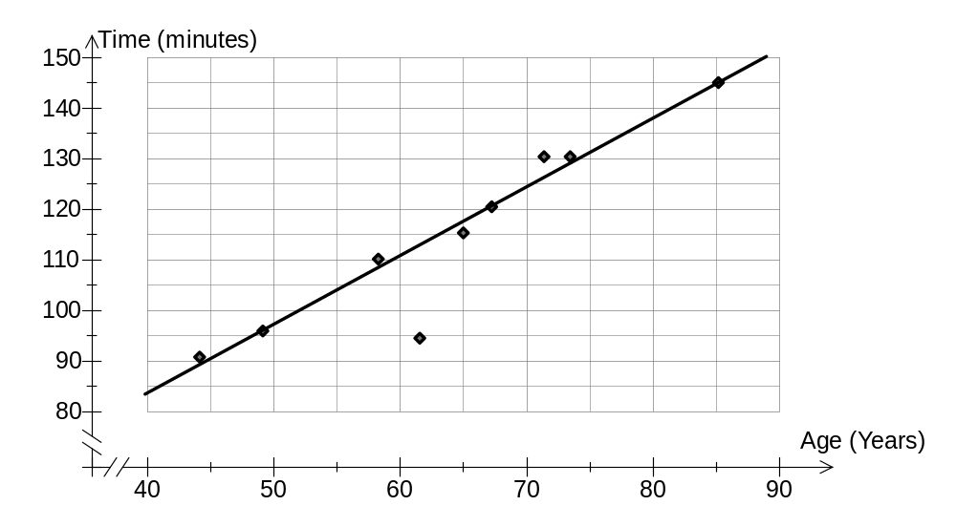
(b) Comment on the relationship between the photograph age and the time spent restoring it.
(1 mark)
Strong, positive correlation.

(c) Draw a trend line for the above data on the graph. (1 mark)

(d) Predict the time required to restore a 55 year old photograph. (1 mark)
(Read from trend line on graph) ~104 minutes.

(e) The time required to restore one of the old photographs does not fit the trend of the other eight. State the age of this photograph and explain why it does not fit the trend. (1 mark)

The 62 year old photo is quite along way away from the trend line compared to all the other eight points.
Question 14 (5 marks)
A set of 35 cards is made up of nine cards numbered 1, seven cards numbered 2, five cards numbered 3, eight cards numbered 4 and the rest numbered 5.

(a) How many of the cards were odd numbered? (1 mark)
20 cards

(b) All the cards are shuffled together and one is chosen at random.

(i) Determine the probability that the number on the card is more than 2. (1 mark)
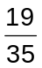

(ii) Which is the more likely; choosing a card with an even number or a prime number? Explain your answer. (2 marks)
A prime number.

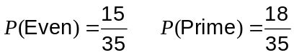

(c) If 180 students all took turns at shuffling the pack of 35 cards and choosing one at random, how many times do you expect that the card chosen would be a 2? (1 mark)

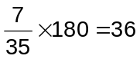
Question 15 (7 marks)
A chrome plating company needs to determine the total surface area of a number of components, to ensure correct chrome finish.

- Component A is a cube of sides 2.45cm (Give answer to two decimal places in cm²)

(i) Find the surface area of one side of the cube (1 mark)

(ii) What is the total surface area of the cube (1 mark)

(b) Component B is a solid cylindrical rod of diameter 12.4 mm by 118.75 mm long

Find the total surface area of the rod. (2 mark)
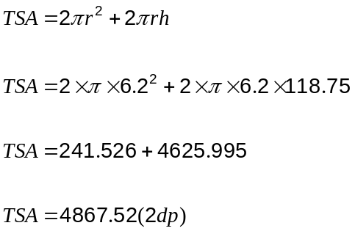

(c) Component C is a sphere with a known total surface area of 726mm.

Determine the diameter of the component C. (To the nearest 2 decimal places) (3 mark)
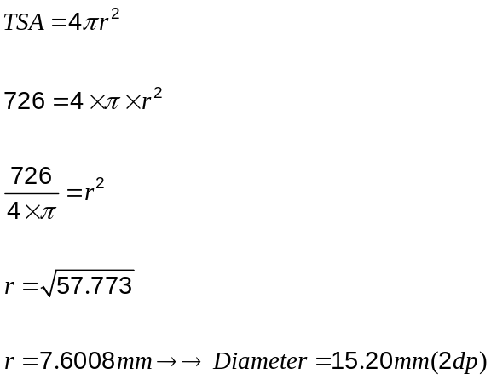

Question 16 (7 marks)
(a) Complete the table below for the rule 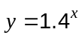, giving your values of correct to 1 decimal place. (2 marks)

 | 0 | 1 | 2 | 3 | 4 | 5 | 6
 | 1 | 1.4 | 2.0 | 2.7 | 3.8 | 5.4 | 7.5

(b) On the axis below draw the graph of . (2 marks)
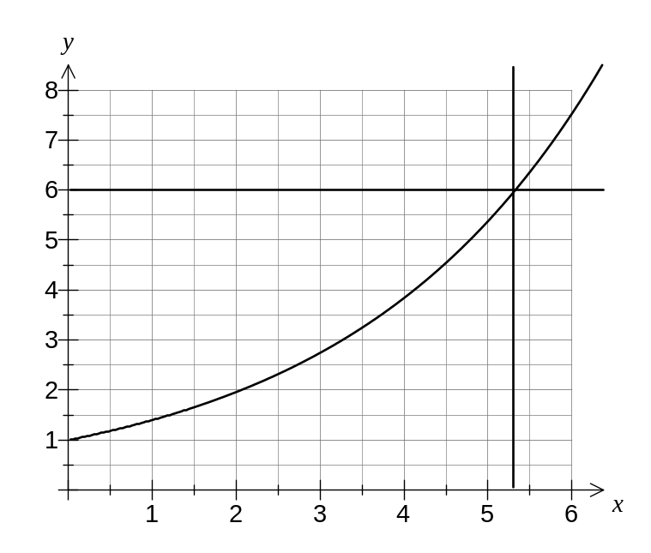

(c) Use your graph to solve the equation 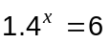, correct to 1 decimal place. (1 mark)

x = 5.3

(d) The relationship between and in the table below is either linear or exponential. State which of these you think it is, explaining how you can tell. (2 marks)

 | 0 | 1 | 2 | 3
 | 1 | 2 | 4 | 8

Exponential.

There is a constant ratio of 2 for the y-values as the x-values increase by 1.
Question 17 (5 marks)
A rectangular sheet of paper measures 21cm wide and 30cm tall.

(a) How long is the diagonal of the sheet of paper? (1 mark)
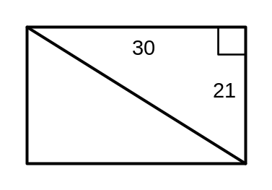
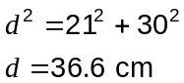

The sheet is cut in half along the diagonal to create two identical right triangles.

(b) Use trigonometry to determine the size of the smallest angle in one of these triangles.
(2 marks)

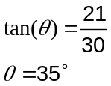

The right triangle is now cut into another two triangles along the line bisecting the angle found in part (b).

(c) How long is the length of this cut edge? (2 marks)

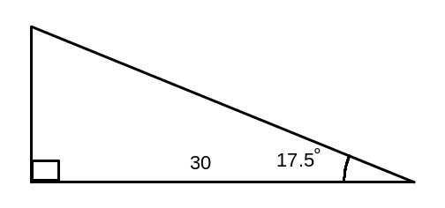
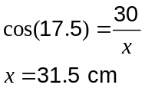

Question 18 (4 marks)
Here are the first four rows of a number pattern.

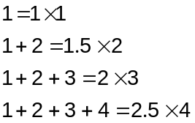

(a) Write down the next two rows of this pattern. (2 marks)
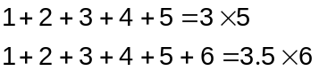

(b) A student made the conjecture that 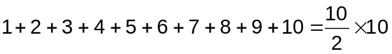. Explain whether their conjecture was true or not. (2 marks)
Conjecture is not true as 1+2+3+4+5+6+7+8+9+10=55 but 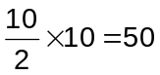, which is not 55.

Question 19 (6 marks)
(a) The probabilities of three events A, B and C occurring are 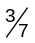, 40% and 0.39 respectively.

(i) Which event is most likely to occur? Explain your answer. (1 mark)
Event A

(ii) What is the probability that event C does not happen? (1 mark)
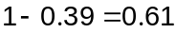

(iii) Another event, D, is more likely to happen than C but less likely than A. Write down a possible probability for D as a decimal. (1 mark)

Any decimal between 0.39 and 0.43

(b) A brand of breakfast cereal is promoting eight different toys made by a company and has randomly placed one of the eight toys inside each packet of cereal.

Describe a simulation you could carry out to investigate how many packets of cereal need to be bought in order to collect at least one of all eight toys. (3 marks)
Make an 8-sided spinner and label each sector with 1 - 8 to represent each toy.

Spin the spinner and record the number it lands on to simulate buying one packet of cereal.

Keep spinning the spinner and recording the number it lands on until at least one of all numbers has been recorded.

Additional working space

Question number(s):

